Design Idea 1
A treaded vehicle design, akin to a tank, but smaller, without a cannon, and simpler for civilian travel

Design Idea 2
A three wheeled vehicle designed like a rickshaw. Two wheels on the back control the turning and the front is a ball bearing without any control.

Decision Table
Criteria | Weighting | Design Idea 1  Ratings | Design Idea 2  Ratings
speed | *5 | 4*5 = 20 | 6*5 = 30
cost | *3 | 3*3 = 9 | 7*3 = 21
size | *7 | 3*7 = 21 | 7*7 = 49
 |  | 50 | 99

Prototype

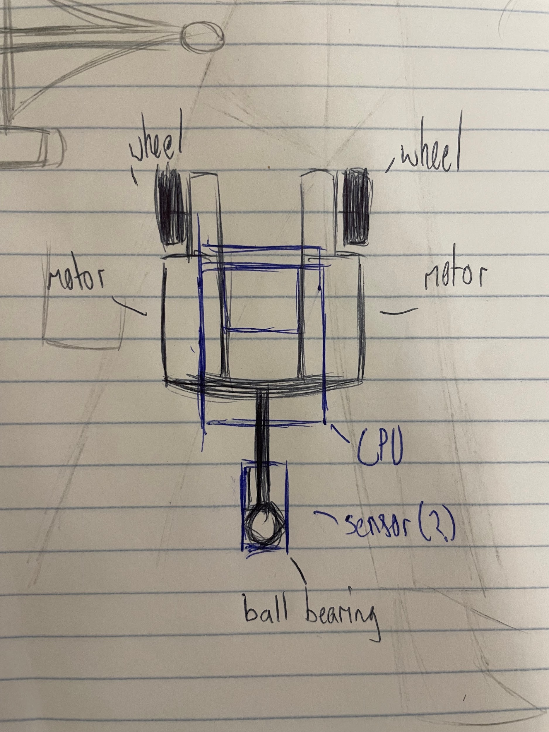

Behavior Model
The vehicle will use a distance sensor to detect walls and trace across a singular side (specifically right) of a wall until it reaches its destinations. It will activate other mechanisms based on the input of the sensors.

